**UNI SAP_BI Antrag Master Workflow**

**24.09.2019 Documentation**

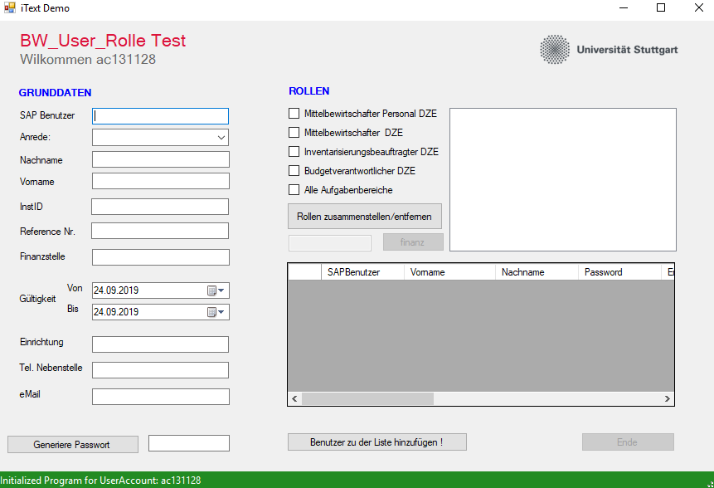

1. **Enter the SAP Benutzer and other details in the respective form fields.**
2. **Click on Generate Passwort to generate a random password for each specific user**
3. **Select the rollen for each user by checking the checkbox item.**
4. **Click the rollen zusammenstellen button to enter the roles or remove the roles.**
5. **You can also enter an additional specific Finanzstelle in the textbox and click “finanz”**
6. **Once the data has been filled, please click on Benutzer zu der Liste hinzufuegen! Button.**
7. **The data shall be displayed in the gridview and status changed.**
8. **Click “Ende” to generate the csv and pdf files**
9. **The status of the generated csv/pdf files shall be displayed in the status area below and files saved in desktop.**
10. **Next. The Outlook Window shall be displayed with the attachments ready to be sent.**

DESKTOP

USER

1. SAP Benutzer
2. Nachname/vorname
3. InstID
4. Finanzstelle
5. Gultig Von:Bis
6. Tel
7. Email
8. Passwort

Rollen -> Users

EMAIL

PDF FILE

CSV FILE